Cloud computing is a way of using IT that as these 5 equally imp traits:

* Customers get computing resources that are on demand and self service
* Get access to the resources from anywhere
* Providers of those resources allocate them to users out of the pool
* Resources are elastic/flexible
* Pay only for what they use

Origin of cloud computing-

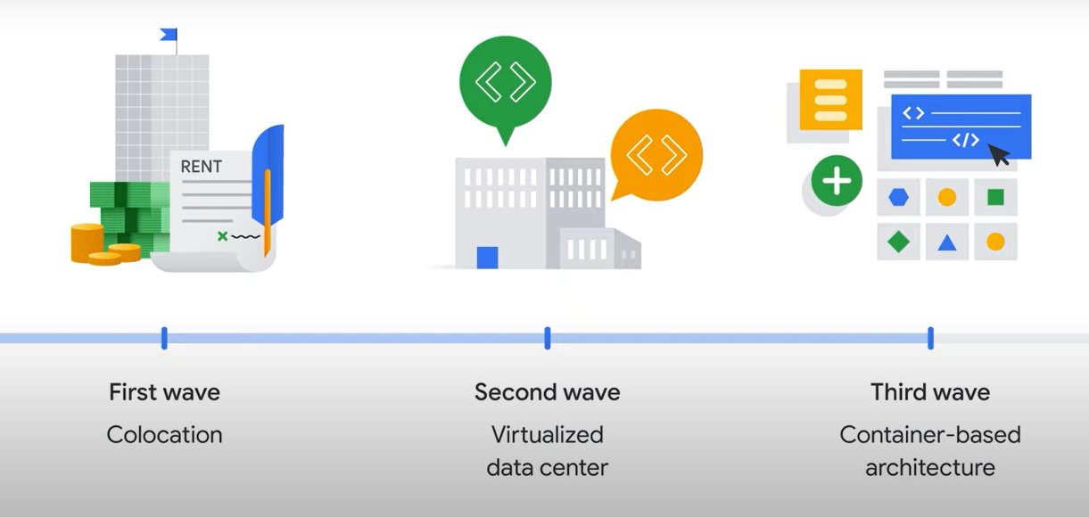

Three types of offerings:

Infrastructure as a service (IaaS):

Provides- Raw compute, storage, n/w capabilities – similar to physical data centers.

Pay for what they allocate

Platform as a service (PaaS):

Binds code to libraries that application needs

Pay for what they use

Software as a service (): apps not installed in your computer

Serverless cloud computing:

Concentrate on code

No infra needed

Cloud functions-

Manages event driven code as pay as you go service

Cloud Run

Deploy containerized microservices based app in a fully managed envmnt.